Dear [name],
Re: Waystar True North Conference
I am writing to request approval to attend True North, Waystar’s client user conference taking place September 9-11th, 2024 in Lake Buena Vista, FL. The conference offers over 40 hours of educational and networking opportunities and is recognized as a leading RCM industry event. I believe this is a worthwhile investment to help our organization thrive in the ever-changing healthcare industry.

Waystar expects more than 300 attendees at True North, including Waystar’s clients and team members who bring high levels of expertise across Waystar’s platform and key industry topics.

True North offers attendees numerous benefits and opportunities to transform their organizations
and roles, including:

+ Educational sessions focused on attendees’ individual needs and goals
+ Opportunities to gain CEU credits
+ Networking with thought leaders and Waystar team members

In particular, I plan to leverage my time at this conference to find solutions or best practices to achieve these goals:

• [Insert goal, e.g., “Increase practice revenue”]
• [Insert goal, e.g., “Improve patient outcomes”]
• [Insert goal, e.g., “Decrease days in A/R”]

I’ve attached a breakdown of estimated costs to give you an idea of the investment for this conference. Based on the advantages mentioned above, I believe our organization can gain a significant ROI from attending.

After True North, I plan to meet with you to discuss the most important takeaways, connections, and recommendations from the conference. We will also have access to breakout presentation materials following the event. I expect to bring back invaluable educational and transformational assets to share with our team.

Thank you for your consideration. I look forward to your reply.

TRAVEL + CONFERENCE EXPENSES
Registration
Registration covers access to general sessions, meals, breakouts, and
demos of Waystar’s latest products and technology.

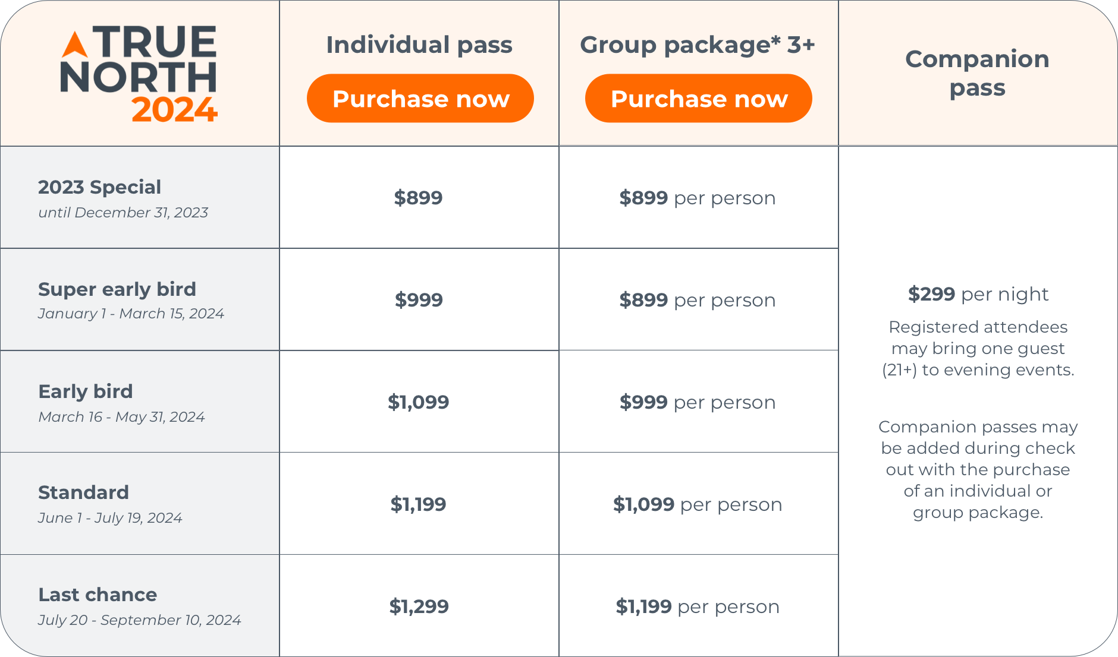

* To register as a group, all members must be added and paid for
in a single registration session. Questions? Email truenorth@waystar.com

Hotel accommodations  Waystar has arranged for a discounted rate of $299  per night (plus taxes and fees) at Disney’s Yacht Club Resort. Reservations and rate are subject to availability. Reduced rate  is active until August 5, 2024. | $299 per night (plus taxes and fees)
Airfare
The closest airport is the Orlando International
Airport (MCO).
Ground transportation  The hotel is 25 miles from the Orlando International Airport. | $50 (estimated)
Estimated cost for registration, travel,
and accommodations:

